AWS Trusted Advisor

# AWS Trusted Advisor

Trusted Advisor inspects the AWS environment to make recommendations for system performance, saving money, availability and closing security gaps

Trusted Advisor checks the following four categories

* **Cost Optimization**
  + Recommendations that can potentially save money by highlighting unused resources and opportunities to reduce your bill.
* **Security**
  + Identification of security settings and gaps, inline with the best practices, that could make the AWS solution less secure
* **Fault Tolerance**
  + Recommendations that help increase the resiliency and availability of the AWS solution by highlighting redundancy shortfalls, current service limits, and over-utilized resources.
* **Performance**
  + Recommendations that can help to improve the speed and responsiveness of the applications
* **Service Limits** ([Circa Nov 2017](https://aws.amazon.com/about-aws/whats-new/2017/11/aws-trusted-advisor-adds-service-limit-dashboard-and-cloudwatch-metrics/) – Latest Addition)
  + Checks for service usage that is more than 80% of the service limit.
  + Values are based on a snapshot, so the current usage might differ.
  + Limit and usage data can take up to 24 hours to reflect any changes

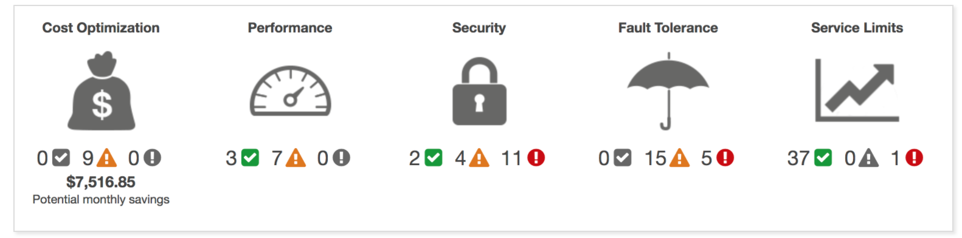

## AWS Certification Exam Practice Questions

1. The Trusted Advisor service provides insight regarding which four categories of an AWS account?
   1. Security, fault tolerance, high availability, and connectivity
   2. Security, access control, high availability, and performance
   3. **Performance, cost optimization, security, and fault tolerance**(Note – Service limits is a latest addition)
   4. Performance, cost optimization, access control, and connectivity